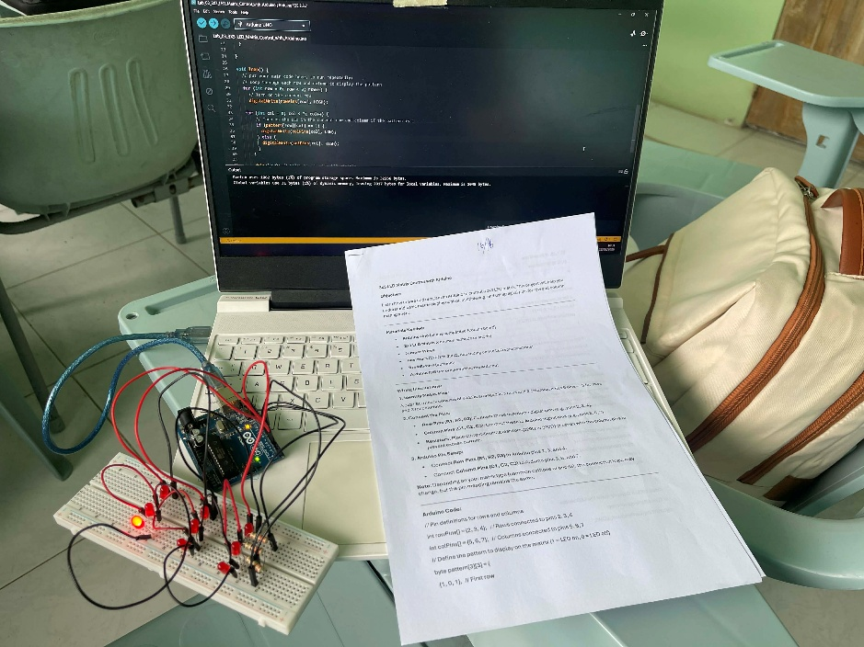
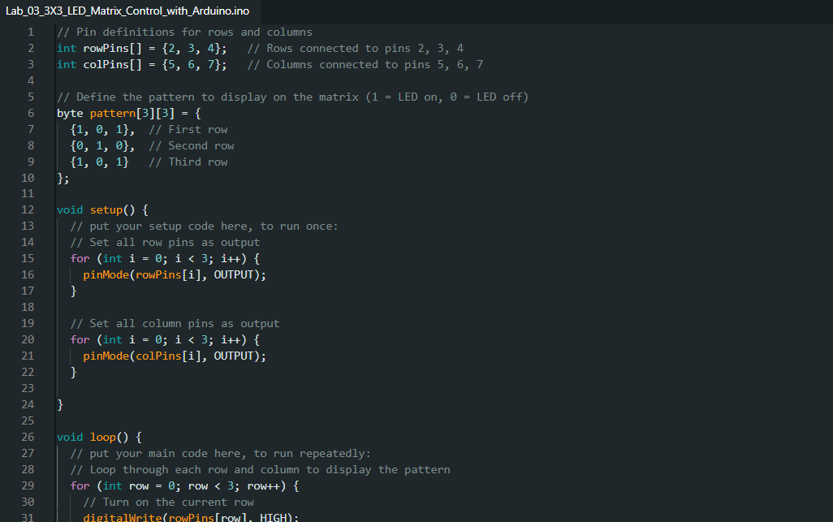
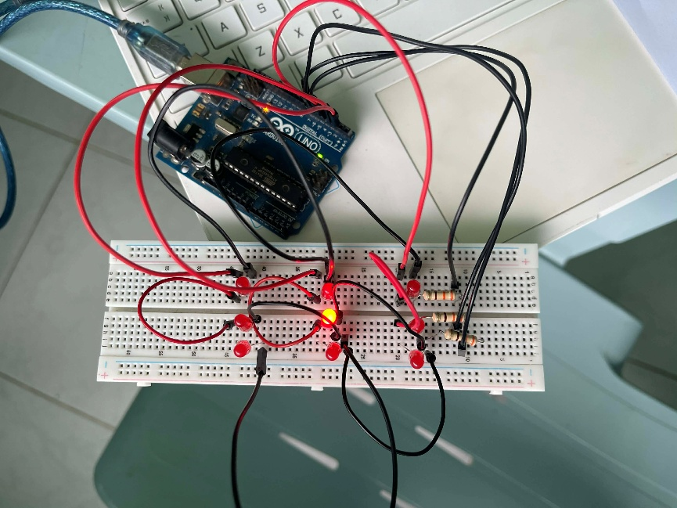
Figure 2: Checked Laboratory Activity
Figure 3: Arduino Sketch
Figure 1: Hardware Set-up

